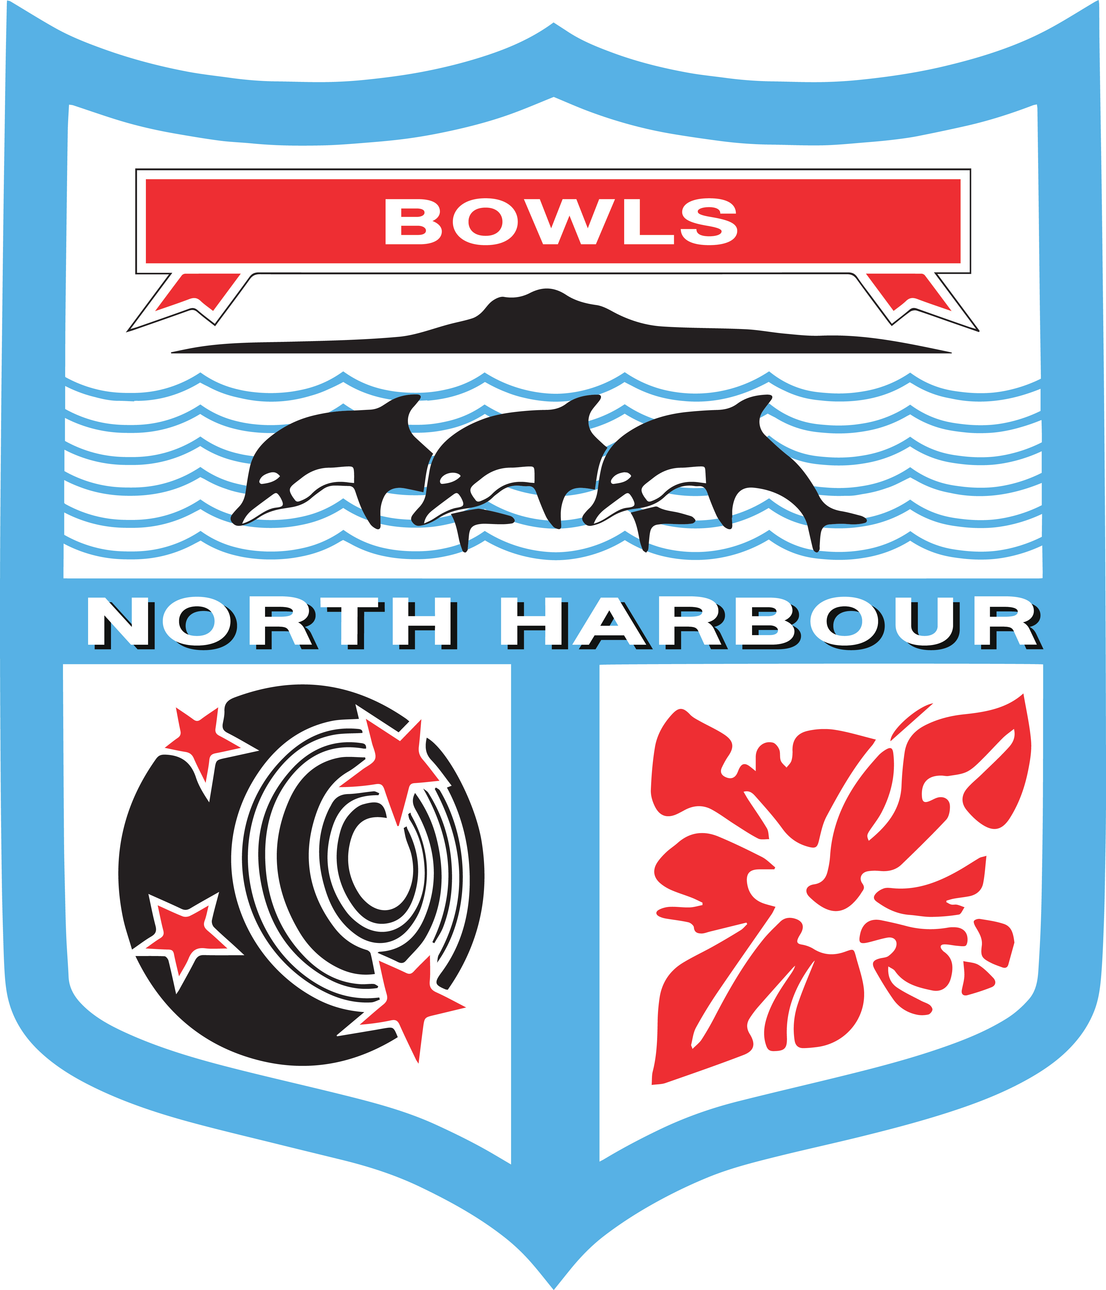

Bowls North Harbour Inc

MINUTES

Type of Meeting: Board
Meeting Location: Bowls Orewa
Meeting Date: Tuesday 17 January 2023
Meeting Time: 5 pm

- Attendance – Maureen Taylor (President), Neil Connell, (Vice President) Robyne Walker (Chairperson), Mike Beretta, Trish Croot, Garth Partridge, Raewyn Thomas (Treasurer), Sandra Sweetman (Centre Manager), Guest Fay Freeman, Freeman & Associates Limited.

- Apologies – Nil

- Fay Freeman gave a presentation on the progress of Regional Bowls Facilities Plan, as it had been developed by Takapuna Bowling Club Futures Planning Committee. BNH had agreed at its last Board Meeting that it would now be progressed by the Centre.

Fay has a background in the administration, promotion, event planning and report writing for Netball, Table Tennis, Tennis, Softball as well as Bowls. Fay has also been a North Shore Councillor and her current business Freeman & Associates specialises in community and sport. They are experts in feasibility studies, strategic planning, community research, project management, community consultation and dispute resolution. Recent clients include Whangarei District Council, Orewa Surf Lifesaving and CLM Sport.
To date 2 meetings have been held at Takapuna Bowling Club with interested clubs including Orewa, Manly, Mairangi Bay, Belmont, Milford, Beach Haven, Northcote, Hobsonville, Sunnybrae, Takapuna and Steve Beel (BNZ Regional Facilities Manager) participating at one or both. At the first meeting, held on 20 September 2022, the meetings’ purpose was to discuss how clubs might respond collectively to the Bowls NZ Facilities Plan which proposes consideration be given to all year round covered (enclosed) bowling club surfaces. It was agreed at the meeting to proceed with developing a North Harbour Bowls Facilities Plan incorporating a possible indoor bowls arena/covered facility at Sunnybrae.
Mark Cameron, Bowls New Zealand CEO, has confirmed their position to be involved and support this initiative where possible.
At the second meeting the clubs had an opportunity to view concept plans of what this could look like and have taken these back to their clubs to discuss. The next meeting will be held by BNH at Sunnybrae Bowling Club.
Fay has proposed that our next step is a needs assessment and feasibility study. This will determine the need and operating viability of an indoor bowls centre (scale, amenities, utilisation, price to be determined etc) at the Sunnybrae Bowling Club site. She believes we should apply for funding from the Kaipatiki Local Board for the feasibility study. Fay has also done a SWOT analysis to use at the forum discussions.

Motion: The Board has agreed that Fay Freeman will be appointed as the ongoing facilitator for the BNH Regional Bowls Facilities Plan and that we will seek a proposal from her in order to proceed with a grant application to the Kaipatiki Local Board for a needs assessment and feasibility study.

Proposed: MT Seconded: GP Carried

- Conflicts of interest – Nil

- Approval of the last minutes dated 7 December 2022

Proposed: RW Seconded: GP Carried

- Matters arising from the last board meeting
  - Email addresses to be standardised is still a work in progress with SS.
  - The Chrome Books have serial numbers to be recorded on the asset register.
  - DOB on BowlsHub can be set at a generic one eg. 1 Jan 1900.
  - The Westpac credit card process is just about complete.
  - TC asked for sponsorship to be advertised on the Website for each of the events. GP to incorporate sponsors on the website and COP. Sponsorship is already on the Weekly Reminder.

- Correspondence
  - 8 December – Brendan Wilson, Orewa, tournament umpires.
  - 13 December – Chris Lander, BNZ re Summerset Nat Singles/Pairs meeting to host clubs.
  - 14 December – Senior Trust re 500 bags 15/12, 500 lollies 20/12, 500 pens 16/12, 500 cloths 9/1 delivery.
  - 15 December – Warkworth complaint re the change to the round robin BNH which was responded to by RW 20 December.
  - 15 December – RW letter to Margaret Oates re her letter.
  - 16 December – Sue Rossiter resignation from Match Committee.
  - 16 December – Simone Spencer, Aktive re Auckland Leaders Forum on 28/12
  - 18 December – Terry Leighton, Milford, issues with the greens being very wet and unable to be used.
  - 21 December – Browns Bay re markers for the Summerset Nat Singles competition.
  - 21 December – SS sending flyer and request for the NZ Masters info being sent to database.
  - 21 December – Tony Poppelwell re the December draft minutes.
  - 7 January – Stanley Bay Bowls re internal discussion on affiliation with BNH. Decision made on 15 February.
  - 10 January – RW email to BNZ thank you for Summerset tournament.
  - 10 January – RW email to Browns Bay thank you for work carried out for Sommerset games.
  - 11 January – Browns Bay thank you for comments.
  - 11 January – Chris Lander thank you for your comments and grateful
  - 11 January – Martin McKenzie great team effort thank you.
  - 11 January – Mark Cameron thank you for comments.
  - 11 January – Dean Bartlett Bowls Auckland re 12 March Premier 1 Men and Women.
  - 13 January – Chris Lander needs confirmation of Nat Interclub 7s entries by 30th January.

- Centre Managers Report – as read

SS is working with Allteams for the email addresses, which is not finalised as yet. SS is working with GP to set up the office chrome book first.

- Chairperson’s Report – as read

- President’s Report – as read

- Masters Committee – as read
The entries are at 220 which is our best entry year so far.
MT to email John Jackson, Senior Trust, to advise him of our record entries and confirmation for the Bowls NZ Live Streaming commentary.

- Match Committee and Greens Report – as read

Bowls Hub Aotearoa Implementation:

Motion: That BNH will be up and running 100% on BowlsHub Aotearoa by 1 July 2023.

Proposed: MB Seconded: MT Carried

We will use the Westpac credit card system in the interim until this is all set up.

Event Programming 2023/24:

The Match Committee have developed a Club Survey that they would like to email out to clubs to solicit understanding of what club members want to see and receive from the BNH programme.
The Board feel that the better way to put the survey to clubs is prior to the Cluster Meeting in March 2023.
TC to put the survey on Google Docs so the Board can put in suggestions. RW to advise Tony P re the Boards next steps. The intention will be to present the questions to the Cluster Meeting. The tentative date is 28 March at Sunnybrae Bowling Club at 6pm. Cluster meeting will extend invites to the Chairman/President, Match Convenor, Delegates from the 19 BNH clubs.

RW to ask BNZ Mark Cameron if the play of the Centre events and lead up to the Nationals could be a little later. January is a busy time for all. Also, the Auckland weather in January is typically very poor, as it was this year again, which is a disruptor to the programme.

- Representatives’ (Open Men & Women and 1-5 Years) Report

Open – as read

TC said the trip had been a success but queried the timing of mid-January as it was always very close to the end of the Nationals. Many players were unavailable. This will be taken to the next Rep Meeting held in March where the next seasons programme is discussed and agreed upon.

1 to 5 Year

A discussion regarding the new event for the Prem 2 Quad team on 18 & 19 March 2023. BOP Rep Convenors believe that it was agreed 5 players should be from Years 1-5 as a Development. This is not the understanding of BNH and the minutes of the planning meeting do not support this.

RW is meeting with Dean Bartlett, new Bowls Auckland CEO, on Thursday 19 January, re BowlsHub implementation and administration so will also add this to their discussions.

- Finance Report – as read

Capitation Fees still outstanding from three clubs – Birkenhead, Stanley and Waimauku.

Lions grant withdrawn because the coach trip for the Reps on 14 January came before the grant was approved/declined. Applications to Lion can only be done once a year.

Westpac for credit cards payments on the Website payments is now in the final stages of being approved. Terms and Conditions are on the Website.

- General Business
      - RW to email Bowls Orewa the BNH COP for Club greens use.
      - Player Point System. These are only for BNH events and any National competition they lead to (National Interclub, National COC and National Intercentre). RW to revise the current Player Points and email out to the Board.
      - Orewa BNH Office – the agreement will expire on 1 Feb 2024 with no right of renewal. BNH to look at options for a new space.
      - Cluster Meeting rescheduled for 28 March, 6pm at Sunnybrae Bowling Club.
      - The set of 8 sets Henselite Dreamline XG bowls for club use, have been loaned to Warkworth for 8 weeks. This is for their Business House Bowls.
      - MB would like to see more coaches in the Centre. Add to the Cluster Meeting Agenda.
      - Office Review – in committee

There being no further business the meeting closed at 8pm.

Next meeting to be 21st February, 5pm, Bowls Orewa.
REPORTS:
Centre Managers Report
Report by Sandra Sweetman

Have attended Match Committee Meeting, Masters Meeting, meeting with Robyne.
Cleaned up the office and set up so that anyone can have a coffee or tea in the room. Also handed out uniforms and labels. Worked on capturing all the previous winners on all events and special awards as well as Presidents, etc. This will be for the website and is an initiative of Robyne’s. Set up the template and basis of the Weekly Reminders for the future. Also started on the NZ Masters Booklet, working with Raewyn and Maureen. Worked through the trophies we have and started making contact to bring in the outstanding ones. Green Allocation and sending emails to all involved for confirmation and the Event Directors.

Chairperson Report
Report by Robyne Walker

I have spoken with Bowls Orewa concerning their charges which they will enforce. The tea/coffee charges may not be enforced.

I attended a meeting held at the BNZ office on 15 December concerning the Summerset Nationals. They were well underway with they preparations and had plans for sunny and rain filled days. I expressed concerns with clubs finding sufficient markers for the Singles games. They were going to allow for this with byes each round so that players would also mark. This will be part of their planning going forward.

The Summerset Nationals were successfully held and Browns Bay Bowling Club did a marvellous job as Headquarters. I have written to BNZ and Browns Bay Bowling Club congratulating them on a job well done. Also, players in BNH did well with Selina Goddard wining the Women’s Singles, Graham Skellern winning the Open Disability Pairs with Bruce Wakefield (Canterbury) and Wendy Jensen and Robyne Walker coming runner up in the Womens Pairs.

The Canon Photocopier issue has still not been resolved. The agent is not returning call or email. I will be going to their offices to escalate in the coming weeks.

Presidents Report
Report by Maureen Taylor

The BNZ Nationals started on 2nd January and I was able to attend going between Orewa and Manly up until the first finals day on 5th January. Was not able to attend after that date due to personal reasons.

Attended Match Committee Meeting with Tony Popplewell, Neil Connell and Sandra Sweetman.

I had arranged for the semi-finals and final of the Men’s Division 1 Pennants for 12th January and they proceeded according to plan. I want to record my thanks to Jenny Daniels for coming and helping me out in an Umpiring capacity. She had a very busy night.

Manly managed to bring along quite a lot of support as did the local team from Orewa which helped the evening to go with more atmosphere. Thank you to Raewyn as well for checking that I wouldn’t be left to close up on my own. Orewa had staff covering the bar and for closing the Clubrooms and the teams all gave them some custom. I have sent my report and photographs to Garth and hopefully he will be able to post them on the website.

Masters Committee
Report by Maureen Taylor

Attended two meetings with Raewyn and Sandra where we went over various items for updating the booklet to be printed and we shall be meeting next week to put the charts in place and team up the single entries. We will also be asking for teams to fill any byes once we have calculated the sections out. I reported last month a total of 69 entries. Yesterday’s figure was 219, which is the largest entry we have had in the three years we have been running. The first year was 196, the second year (which had to be cancelled) was 218 and by the time we meet on Tuesday I hope it has gone up yet again.

I have arranged to meet with Tony on his return on the 25th January. Tony has spoken with Colin and he is willing to help this year again. It would help considerably if we were able to put the playing programme on BowlsHub.

Match Committee
Report by Tony Popplewell

COMPOSITION – Since the last meeting when Graham Dorreen was appointed, we have had the resignation from the committee of Sue Rossiter. This was disappointing as Sue’s background would have been valuable to the committee. As mentioned in the last report we would value an additional member and preference should now be directed to finding a female member to ensure their representation is added to the committee.

PENNANTS MEN’S DIVISION 1 - The semi-final and final were completed on Thursday night with Manly running out the winner of this division. Browns Bay was runner-up.

CHROME BOOKS – With the holidays and national tournament on, the progress towards setting full generic sign-on has not been progressed yet but will be scheduled as soon as the people are available.

BOWLS HUB – Referring to our report to the last Board meeting we still need a decision from the Board as to where this programme sits. The MC are still keen for this to be further developed for Centre wide use but an education programme needs to be implemented for the clubs.

I have spoken to Colin Williams at BNZ and he is willing and able to assist BNH in the education and development of the system. The BNH Board needs to set a date, suggested as the beginning of next season events, and work towards that with sufficient training and education provided to club members.

EVENT PROGRAMME 2023/2024 – We are in the process of seeking views from clubs on aspects of the overall programme of events before the committee considers next season’s calendar of events. This is work in progress and we hope to be in a position to develop the first draft of the programme in mid-late February. A copy of the circular and survey form is attached. Whilst this is designed to solicit understanding of what club members want to see and receive from the BNH programme, the MC have yet to discuss whether there will be any changes proposed to the standard programme of events of late.

REVIEWING OTHER CENTRE PROGRAMMES – It is interesting to view other Centre’s approach to the staging of Centre events and while there are some variances of approach there are a number of common themes as well. We need to consider these to ensure we are providing the best programme for our participants.

GREENS ALLOCATED – The MC have now allocated greens allocations for all events up to end of July. These will be advised to clubs seeking their confirmation that they will be able to accommodate the Centre events proposed for their club greens. This would involve the clubs providing a results recorder and advising the results to the Event Director.

EVENT DIRECTORS – We have four event directors able to take responsibility for the event management and recording of the results of the competitions. A schedule of duties has also been prepared. The directors available are Maureen Taylor, Garth Partridge, Chub Roberts and Tony Popplewell. All four have been allocated various tournaments through to the end of July.

MASTERS EVENT – The MC will be assisting the Masters Committee in the preparation for the draws and club allocations involved in this competition.

Representatives’ Report (Open Men & Women and 1-5 Years)

Open Report:
Report by Robyne Walker

The Open Men and Women’s Prem 1 and 2 teams went to Katikati on 14 January and played two games against the BOP team. I spent a considerable amount of time compiling the travel schedule and getting team lists to the BOP Centre Manager, Paul Hunt.

Raewyn booked the bus from Bayes Coaches who were very good to deal with. Thank you, Raewyn.

The day was very successful for BNH who came home with the trophy.

1 to 5 Year Report:
Report by Garth Partridge
1-to-5-year bowlers in the North Harbour district have been active and successful in club competitions and many participated in the Bowls New Zealand Nationals. The high standard of skill was demonstrated in some of the results, with a 1 to 5 Woman bowler winning her singles match in the qualifying round, against the current National champion. There were others who qualified for post section play and even those who did not benefitted from being involved in competition at this level.

The trip to Omokoroa for the head-to-head against Bay of Plenty saw the 1 to 5 Women maintain their unbeaten results in competitive play and the 1 to 5 Men improving their results. Both 1 to 5 squads won their sections of the competition and helped the overall Bowls North Harbour team to win the trophy, which it now holds and which needs to be engraved.

Thanks to the coaches, Warren Sequee and Greg Yelavich and to Ian McKenzie, the Men’s 1 to 5 Manager. Transport to and from went smoothly and was very comfortable. The hosting at Omokoroa was first rate.
This was the first time the 1 to 5 squads have been included in this head-to-head and the inclusion added to the overall event and should be continued from now on.

Finance Report
Report by Raewyn Thomas

ACCOUNTS:
Attached to this report is the Profit & Loss (P & L) and Balance Sheet (B/S) as at the 31ST December 2022.

GRANTS:
Four Winds Foundation has approved $9.347.00 towards Centre Manager and Treasurer wages for 3 months
Rep Travel to Christchurch – Accommodation and Airfares – Still awaiting outcome from Racing Industry
Coach Travel to BOP – Coach Hire – still awaiting outcome from Lion Foundation
Medals – Masters - Declined

Credit Card Payments for Tournament Entries
I have contacted Westpac and have begun the process of resurrecting the application to use the E Way system of credit card payments. Allteams are in the process of putting the Terms and Conditions onto the Website and also onto the entry form system.

Capitation Fees:
There are three clubs still to pay their Capitation Fees. Waimauku, Birkenhead and Stanley. Invoices were resent on the 3rd January.

Masters Entries
As of the 3rd January we have 154 paid entries for the Masters.

Raewyn Thomas
Treasurer

