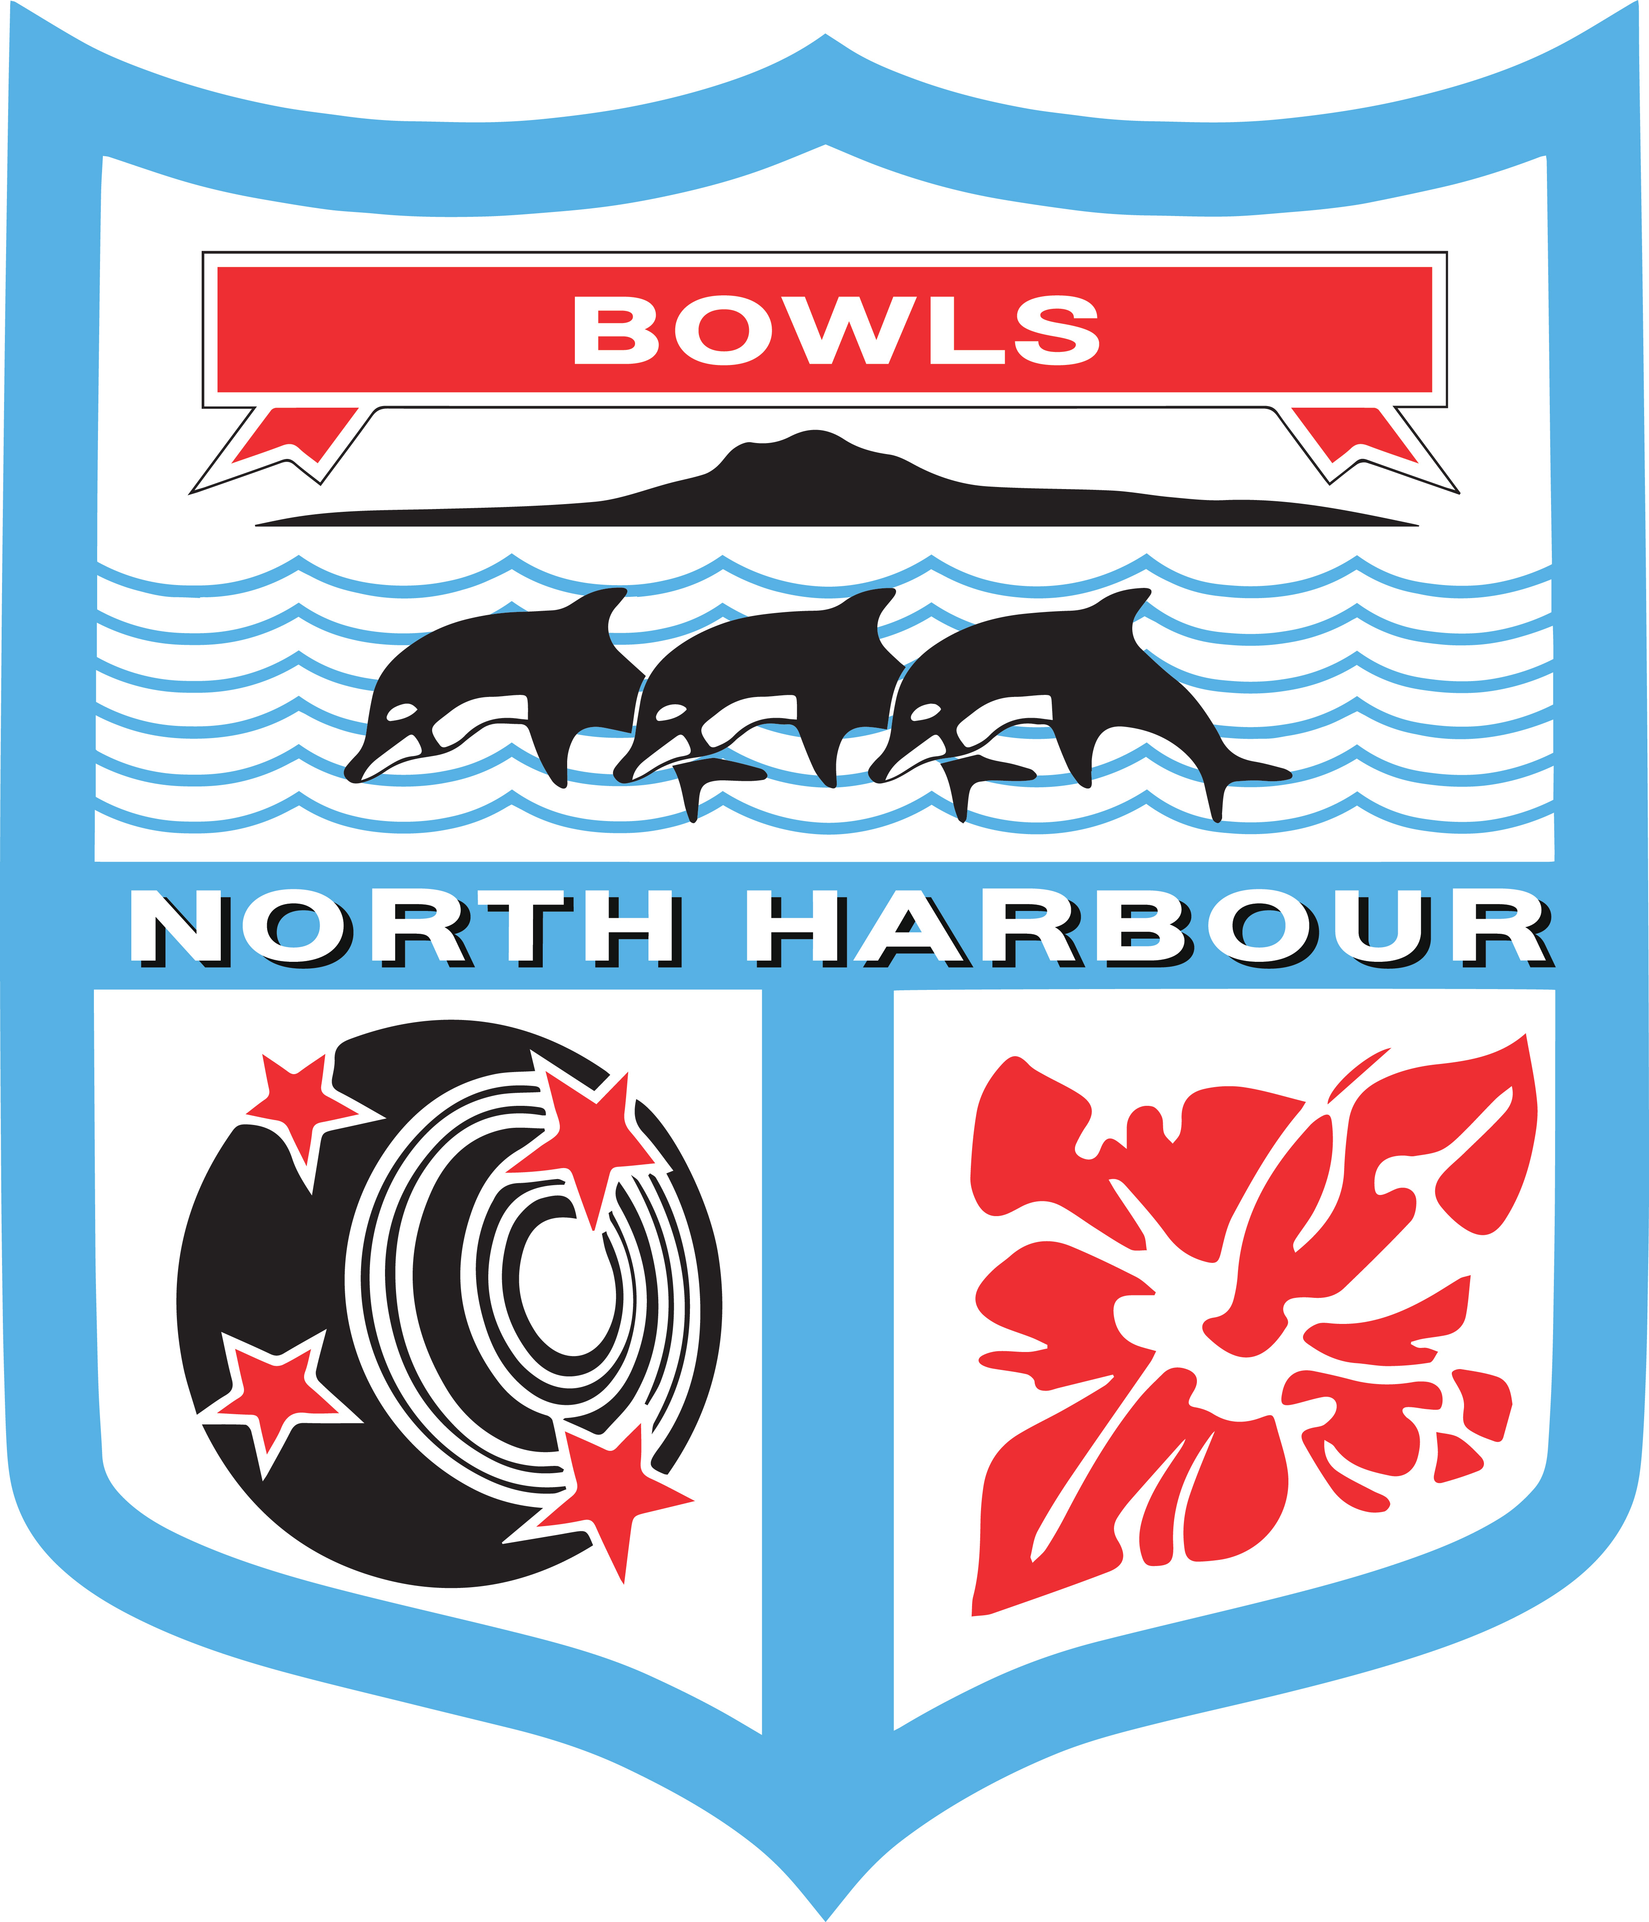

Bowls North Harbour Inc

MINUTES

Type of Meeting: Board
Meeting Location: Bowls Orewa
Meeting Date: Tuesday 14 July 2022
Meeting Time: 5 pm

- Attendance – Maureen Taylor (President), Neil Connell, (Vice President) Steve Yates (Chairperson), Raewyn Thomas (Treasurer), Mike Beretta (by Microsoft Teams), Trish Croot, Garth Partridge, Robyne Walker.

- Apologies – Nil

- Approval of the last minutes dated 14 June 2022
Proposed: TC Seconded: MT Carried
- Matters arising from the last board meeting.

Nil

- Incoming Correspondence
  - BNZ Insurances and other information.
  - BNZ email re Bart Robertson who was allowed to get dispensation for COVID and Helensville the opportunity to have a substitute. Bart declined and was well enough to play in Naenae, Hutt Valley.

- Centre Managers Report

Included in the Chairmans Report as Steve Yates still acting BNH Centre Manager.

- Chairman’s Report

In Committee – 5.10 to 5.35 pm

With regard to the Representative Management the following motions were processed:

  - The 1-5 Years Representative Coach/Selector/Management team is confirmed for the 2022/23 season with -
- Ian Mackenzie (Overall Men’s and Women’s Manager and Men’s Communications Manager)
- Warren Sequee (Men’s and Women’s Coach and Selector)
- Greg Yelavich (Men’s and Women’s Coach and Selector)
- Judy McSweeney (Women’s Selector)
- Garth Partridge (Women’s Communications Manager and Selector)
Proposed: MT Seconded: MB Carried
  - Open Men’s Representative – the incumbent Gary Stevens is retained for the 2022/23 season following a review done by Steve Yates, Representative Convenor, at the end of the 21/22 season. Gary will be responsible for appointing his management team.
Proposed: SY Seconded: MT Carried
  - Open Women’s Representative – with the resignation of Graham Dorreen from the coaching, selecting and management of the women’s team this position will be advertised by Bowls North Harbour. This will be done immediately with someone to take over mid August 2022. The Open Women and Men have their first representative games on 15 September 2022 at Remuera Bowling Club.Also, the Women, having won the Region 1 Inter-centre Tournament are due to play the finals at Browns Bay 15-16 October 2022.

- President’s Report

As read.

- Match Committee and Greens Report

Match Committee:

The Match Committee has agreed to appoint 2 experienced players and administrators – Norma Klaussen and Chub Roberts onto the Match Committee. Both Norma and Chub have a wealth of tournament experience and would bring this to the committee.

Trish Croot asked if BNH could look at Match Committee training sessions for those club members new to the MC position. There is a link on Bowls New Zealand https://bowlsnewzealand.co.nz/wp-content/uploads/Doc-Jul-27-2020.pdf that is described as a “Book of Draws”. BNH would like to adapt this to make this BNH friendly. Trish Croot has offered to do this.

Neil Connell requested a review of the payments made to Tournament Directors and Recorders. The latter are not currently paid.

Motion: To increase the Tournament Directors fee per tournament per day to $50 and implement a new payment to Recorders per tournament per day of $30.
Proposed: NC Seconded: MB Carried
Maureen Taylor asked for the Match Committee to have the old BNH laptop to email and do Match Committee work on. Trish Croot offered to strip all the unnecessary information from it so it could be used. The Chromebooks would continue to be used for BowlsHub Aotearoa only.

Greens:

Neil Connell and Tony Rickerby are going to inspect greens on 30 July 2022. A number of the grass greens will be still in reconstruction, but it is a great opportunity for Neil and Tony to touch base with the clubs and talk to the members or contractors that tend the greens.

- Representatives’ (Open Men & Women and 1-5 Years) Report

As read.

The Stanaway Cup, Manly, is now run by Andy Dorrance. Garth Partridge has offered to introduce Tony Stanaway to Andy.

Latimer Cup, Browns Bay, is being filled by Browns Bay on a first come first served. This means that most places are filled by their own teams. It would be beneficial to the BNH Centre if there could be a wider pool. Steve Yates to speak to Browns Bay regarding this.

- Coaching and Development Report

Mike Beretta was very pleased with the way the programme went this year. Thanks to Bowls Orewa for the facilities and hospitality by their members. Especially at the last training session and BBQ which was a great way to finish.

- Marketing and Sponsorship Report

As read.

In addition, Steve Yates has spoken to and suggested opportunities with Dynasty (Sports Clothing) for uniforms, Dynamic Sports (Nigel Morgan) who sells Hensilite and Taylor Bowls and Ryman Healthcare for additional sponsorship around Market Days, Tournaments, and training at their villages. Steve will follow these up and advise next steps to the Marketing/Sponsorship Portfolio leads.

Trish Croot also suggested we approach Benefits for flags and banners at a reasonable cost to clubs. This follows the comments received at the Awards ceremony by bowlers that could see the benefit at their premises. Trish and Robyne will assist the clubs with this.

- Governance Report

As read.

Robyne Walker requested Board Members review the BNH Financial P&P’s that she emailed to the Board as well as the Delegations of Authority drafted by SY and come back with any comments to her by Friday 22 July 2022.

- Finance Report

Following the successful Winter Coaching at Bowls Orewa they have invoiced us for the greens plus tea/coffee. OK to pay.

Garth Partridge suggested a new GL code for Board Honorariums other than them going in a General Expense code. This was agreed by all and the code will be called “Board Honorarium” and will be set up by the Treasurer.

- General Business

  - NZ Masters venue for 2023 (MT)
The venue is to be decided. Maureen Taylor has emailed Ryman to ask if they have a preference.
  - Orewa Bowling Club (MT)
Steve Yates to meet with David Batchelor.

In Committee 7.10 to 7.20 pm.

Steve Yates to email out Cluster Group suggestions and delegate Board Members to a group eg. Robyne Walker = Takapuna, Milford, Belmont and Stanley Bowling Clubs.

Next Board Meeting – 16 August 2022

Chairman’s Report for 12th July 2022 Board Meeting

- BNH AGM
The AGM was well attended by our Delegates and a quorum was easily reached. The preparation od documentation, quality of packs for delegates and venue was excellent. Congratulations for all Board Members involved in the preparation from providing advance notice to all delegates of when the AGM was being held through to the completion of the event.
Also, the outcome of the President and Vice-President resulted in both Maureen and Neil being re-elected for a further term. Many thanks to Lesley Langer for being nominated for both roles by Browns Bay Bowling Club. The Board of BNH remains as status quo with Steve and Trish being elected as Board Members for a 2-year team.
Following the AGM, the Board met to appoint a Chairperson until the next AGM in 2023 and Steven Yates was elected unanimously.
Finally, we have 1 vacancy for a Board Position where we have the opportunity to Co-opt a suitable candidate.

- BNH Awards Function
In my personal opinion this event was by far the most professional Awards Function held in recent years. A special thank you to Trish, Robyne and Maureen for all of your efforts in making this event such a success. The feedback from all that attended was very positive.
I would like to also acknowledge Takapuna Bowling Club for their outstanding hospitality, Bowls NZ for both Mark and Martin, our Sponsor Ryman Healthcare with Steph attending and the excellent work of our MC Miles Davis.
As a Board we have set the benchmark for all future Events.
The only disappointment of the function was absence of some clubs and players that won awards and weren’t present to receive their awards.

- Secretary Report
I have spent a significant amount of time preparing for the AGM to ensure that all constitutional requirements were met, and that all documentation was correct. I have also spent a lot of time sending and returning emails, updating the Website, compiling, and completing tournament draws and attending to phone calls.

I have met with 3 potential candidates to fulfil the new Centre Manager role and I will provide the Board with an overview of her skills and experience for consideration. The closing date for applications is Friday 15th July at which time I will be looking to make a decision.

- Representative Update
I have received confirmation from Graham Dorreen that he will resign from his position as Head Coach/Selector of our Open Women’s Representative with immediate effect. While this is a disappointing outcome for BNH (due to Graham’s success) we must discuss as a Board how we proceed with finding a suitable replacement especially considering we have the National Intercentre Finals in October.
As agreed, we will re-appoint Gary Stevens and his Management Team for a further 12 months and review the position following the 2023 AGM
I am still to meet the 1-5 Year Management Team to conduct their End of Year Review and will conduct ASAP.

President’s Report for Board Meeting July 2022.

Chub Roberts and I met at the Office in Orewa to plan the Winter Cup. Unfortunately only two of us were available but due to time restrictions we had to move quickly.

After a few phone calls we managed to get permission from Warkworth, Mairangi Bay and Hobsonville to use their greens to run the competition. We also checked the Conditions of Play, changed some points to fit with this year’s competition and passed it forward to Steve to take care of the draw. Chub offered to run the Men’s competition from Hobsonville with the results being sent through from Warkworth after each round and I volunteered to run the Women’s competition from Mairangi Bay.

I wrote out 3 weeks of the score cards for Warkworth and arranged for them to be taken up to Warkworth by David Batchelor along with COP and charts. Also wrote out score cards for the Women’s competition.

I have nothing at all to report on the MASTERS apart from a phone call from Raewyn who had been contacted by someone asking if the Masters was being held at Orewa in 2023. The venue is something we should be discussing very soon. I have already been approached by Birkenhead who would like to be considered. Previously it has been July that we heard from Ryman Healthcare confirming the Sponsorship being given to BNH.

Maureen Taylor

MATCH COMMITTEE AND GREENS REPORT

Match
1st day of winter cup was cancelled due to weather conditions.

Greens
Most clubs should have received their Maniototo or Starweed seed by now and waiting for drier weather to seed the greens.

Regards.
Neil Connell, Chairman Match Committee.

REPRESENTATIVES (Open Men & Women and 1-5 Years) REPORT

- Open Reps Report

See the Chairman’s Report above.

- 1 – 5 Year Reps Report to the Board – July 2022

- attended all the Saturday morning in June training sessions held at Orewa. Great feedback and a job really well done by Mike Beretta. Numbers: week 1 - 32, week 2 - 38, week 3 - 28 (other club events on), week 4 - 33

- Attended the Sorrill Cup at Browns Bay. As this event now includes up to two 6 to 8 years players in the team the standard of play was a mixture of teams that were relatively new and teams that were incredible strong. The competition was strong with no team recording 4 wins.

The winning team from Orewa featured all four bowlers who are in the Men’s 1 to 5 Representative squad.
Warren Seeque was also at the event to observe form.

- continuing to act as the communications manager for the Women’s 1 to 5 year squad. Judy McSweeney has agreed to be the team manager / selector. The trials were held and the squad of 15 is to be announced the week ending 17 July. 2 squad training sessions are planned prior to the opening event, the head-to-head against Waikato at Remuera on 28 August.

Men’s and Women’s squads to be announced on the BNH website after all players have had one on one contact with the managers.

- met with Ian McKenzie, Warren Seeque and Greg Yelavich to select the 1 to 5 representative sides for the upcoming season

- Latimer Cup to be held on 7th August at Browns Bay entries are full – 16 teams.

- Stanaway Trophy to be held at Manly on 24th August. Manly to invite Tony Stanaway to present the trophy. Limited to 32 teams. Winner of the trophy must be from the Bowls North Harbour District. No composite teams.
Garth Partridge
COACHING AND DEVELOPMENT REPORT
We have completed the Winter Coaching sessions at Orewa. The turnout has been fantastic with over 30 players in attendance at each, the feed-back has been positive.

Regards, MIKE BERETTA

Sponsorship and Marketing – Report June 2022

1. | Brand Implementation – Project 1.  COMPLETE | - Updates to logos and media are complete.  - Templates created – email signatures, letterhead, and Facebook imagery complete.  - Brand identify guide folder shared to BNH.  4 Flags and 1 banner have been printed and delivered to us ready for use. Waiting on spikes. Currently have two concrete bases. New design colours, logos etc with Benefitz. (At this stage we have nominated them as our supplier because of potential ongoing sponsorship).  Awards certificates updated – with Snap Printing. New background, fonts and logo. PowerPoint presentation 80% the way there – new background.  Awards Programme – completed and feedback has been very positive.  Awards Guide / Folder – document & information for future use to be completed and put on BNH computer.
2. | Website Development – Project 2. | Re-development project for the website. New wireframe – 1-click access. Re-do imagery. Up-to-date information updated weekly. Examples: Mairangi Bay. – Mike Hargreaves (from ALLTEAMS) has been contacted and we are waiting for him to come back to us with “next steps”.
 | Social Media upgrade / content rollout –  Project 3. | Develop template and social media campaign BNH Standard template for news / newsletters featuring updated brand standardisation. Will flow into website.  FB banner – sent for uploading.  Photo standards. What’s a good photo look like? Can the originals be sent to BNH for print use – where are they stored?
 | Sponsorship packages – Project 5. | What does sponsorship look like for BNH? Develop strategy and packages across the calendar year. Develop a “how to package for clubs”. What does that look like for them eg. profiling sponsors, keeping them in the face of members regularly. What does commercialization look like for clubs where the club is developed for the local community use? What are the successful things that clubs are doing already? Beach Haven, Birkenhead, Takapuna, Orewa, Manly ? Let’s case study this for others. Nothing to report
 | Barefoot Bowls – media campaign and rollout for clubs Project 4. | Social media campaign to get people into clubs for the clubs to use on their own social media sites. See P6 below.
 | BNZ – media and rollout for clubs (define this)  Project 6. | Discuss marketing with BNZ and quantify their goals for 2022-23 and into the next 5 years. Bowls 3/5? – Look at program.

GOVERNANCE REPORT

The new governance manual has been started and will be circulated in due course for comment. This will be delayed with my absence from 28 July to 29 August 2022.

As I build up to the full governance manual I have concentrated on 2 drafts – Match Committee and Financial Reporting & Internal Control.

The Match Committee draft has been circulated to Neil Connell, Maureen Taylor and Steve Yates for their edits. Once done this will be circulated to the Board.

The Financial Reporting and Internal Control has also been completed in draft and is attached to this Agenda. It covers the areas of maintenance of accounting records, purchases, payment of accounts, bank accounts, budgets, financial reporting, adherence to NZ IRD and government, audit, people management, supply contracts, membership fees and the Bias Fund. There is also a Delegated Authorities chart.

Steve Yates has also produced a draft Delegated Authority paper for discussion that was sent out to all Board Members on 6 July 2022.

Robyne Walker

REPORT TO BOARD FOR JULY 2022 MEETING

Accounts:
Attached to this report is the Profit & Loss (P & L) and Balance Sheet (B/S) as at the 30th June 2022.
End of Year accounts have been completed and signed off by the Auditor.
Westpac Coaching Bank Account.
Paperwork has been submitted to Westpac and is in the process of being closed.
Bias Fund
There have been eight grants paid from the Bias fund this month.
Budget
The budget has been completed and entered into MYOB.
Term Deposit
The term deposit for $20,000 matured on the 21st June 2022 and has been reinvested for 12 months with an interest rate of 3.15%. The term will mature on the 21st June 2023.
Incorporated Societies
The financial statements and Review Letter have been filed with the Incorporated Societies for year ended 30th April 2022.

Raewyn Thomas
Treasurer
4th July 2022

