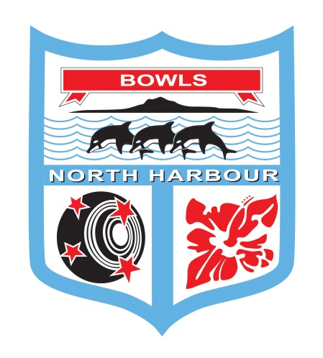

Bowls North Harbour Inc.

2021-2022

WOMENS

PAIRS

**18 and 19 June 2022**

**EVENT DIRECTOR – Maureen Taylor**

**HEADQUARTERS**

**MANLY BOWLING CLUB**

**56 Laurence St Manly Ph: 09 420 8316**

*For any cancellations – please check the Bowls North Harbour Website & Facebook Page*

**Womens Centre Pairs**

**CONDITIONS OF PLAY:**

1. **Laws and Regulations:** Played under the **Laws of the Sport of Bowls** and Bowls New Zealand Domestic Regulations as applicable.
2. **Controlling Body**: The Controlling Body for this event is the Bowls North Harbour Match Committee. The Controlling Body will have the right to alter, add to or delete any conditions of play and/or special conditions to enable the completion of the tournament.
3. **Code of Conduct:** All players will comply with and observe the requirements of the “Code of Conduct for players at Bowls North Harbour Event” as set down in the Bowls North Harbour Centre Handbook.
4. **Contact between players:** At the beginning of the game and the end of the game the Controlling body have recommended that physical contact between players is no longer encouraged
5. **Clothing**: All players in a team event, or singles players in a singles event, shall wear their club uniforms or other matching sports clothing which is suitable for playing the game of bowls. This means the same shirts and coloured pants (long or short is acceptable) or skirts. Logos that conflict with the event or Bowls North Harbour sponsors will not be permitted. In inclement weather jackets or other suitable outer clothing is acceptable.
6. **Postponements:** Any postponements due to weather conditions will be on the Bowls North Harbour Website & Facebook page.
7. **Mobile phone:** Use is not permitted by players on or alongside the greens during play. It is preferred that cell phones are switched off or turned to silent.
8. **Smoking Policy:** There shall be no smoking on the greens or immediate surrounds. Smoking areas will be designated at each venue as advised by the host club duty officer. Please be advised that some clubs in North Harbour are completely smoke-free clubs.
9. **Alcohol Policy: Alcohol shall only be consumed in areas defined by the host club liquor** licence and in no event be allowed on the green or surrounds during play.
10. **Late Appearances:** When any player has failed to be in position to commence play **15 minutes** after the scheduled starting time, the game will be awarded to the opponent.
11. **Entry Fees and withdrawals:** Entry fees will be refunded to late entries and entries not accepted. No refunds will be made to teams or players who withdraw after the draw has been made. Any withdrawals must be notified to the Bowls North Harbour office by 12 noon on the day preceding the scheduled commencement of the event.
12. **Defaulters:** No team or singles player will withdraw except in the case of illness of a player or other just cause. The Controlling Body may require evidence of the illness or other just cause to be submitted.
13. **Use of greens** – Bowls North Harbour acknowledges that clubs provide their greens for use in the organisation of centre and national events. At times there may be particular requests by clubs/greenkeepers for play to be in a certain direction and this may well be changed during the course of the event and in some cases during the day. Any such requests are approved as a condition of play for the event.
14. Trial Ends: Before the scheduled start of play for the first game of the day or before continuing an unfinished game on another day, one trial end may be played in each direction. A team which has a bye may practise, if it is to play an opponent which has already played a game on the green that day.  Practise must not be on the rink the bye team about to play on, however the bye team may have trial ends on the rink to be played on. If it elects to do so, the opposing team may also have trial ends on that rink.  Refer to Laws of the Sport of Bowls Law 5.1.
15. **Complaints:** The Bowls North Harbour Match Committee will act on any complaints and all playing disputes, provided they are in writing, to the Bowls North Harbour Events Manager.
16. **Breach of Conditions of Play:** Where the Conditions of Play have been breached by any club, team or player then the Controlling Body for the event may take such action as to disqualify, fine or impose such other penalty against the club, team and/or player. Such action may result in the club, team or player from participating in further Centre competitions until the penalty has been discharged.
17. **Media and Communications:** Bowls New Zealand and Centres reserve the right to use any video and photographs taken during this event for further promotional requirements.

**SPECIAL CONDITIONS OF PLAY:**

1. **Play will commence by**: 8:30am on Saturday 18th and 9.00am on Sunday 19th June 2022.
2. **Bowls:** Each player will play 3 bowls in each end.
3. **Qualifying**: Entries will be drawn into sections of 4, a round robin of 3 games of 18 ends or 2 hours. All games in qualifying MUST be completed IN FULL if the result has any bearing on the potential qualification of any team within the section.
4. **Defaults:** If a team defaults their score will be recorded as a loss. The non-offending team will be awarded a win and the average net total of shots scored by the winning teams in the same round of the same section.
5. **Dead Ends:** If an end becomes dead it must be replayed
6. **Time limit:** A time limit of 2 hours will be applied in qualifying play and post section games apart from the final. If the jack has been delivered before the time signal the end will continue and if it subsequently becomes dead it will be replayed.
7. **Ties in qualifying play:** If a game is a tied at the completion of 18 ends, or at the time limit, then both teams will be awarded 1 point.
8. **Determining a section winner:** Three points will be awarded for each game won. 1 point will be awarded to each team if a game is tied. Where game points are equal the winner of each section will be the team with the highest net total of shots. If the game points and the net total of shots are equal the team with the lowest “total shots against” will be the winner. If these are equal, the team that won the game when the two teams met will be the section winner.
9. **Restricting the Movement of Players During Play:** In all games, players will only be allowed to walk up to the head under the following circumstances:

Leads: after delivery of their third bowl.

Skips: after delivery of their second bowl.

1. **Post Section:** The winner from each section will go through to Post Section play on Sunday 19th June at Manly Bowling club commencing at 9.00am. Post Section will be sudden death, 18 ends. There is a 1 ¾ time limit for all post section games apart from the final. Each player will play 3 bowls in each end.
2. **Inclement Weather:** During qualifying play, if weather conditions affect play a minimum of eight [8] ends will constitute a game. If weather forces abandonment of play, 2 completed games will constitute completion of section play, and a result found from the 2 completed games. Each venue will be considered a separate competition when applying this rule. If weather forces abandonment at any one venue before the completion of at least 2 games of qualifying, the balance of events will be transferred to Day Two. If Day Two play is affected by weather conditions, the balance of games will be transferred to the next available reserve day.

*The presentation of the Huapai Sports Store Trophy will be made to the winners on the green immediately at the conclusion of the final. Prize money will also be paid to all the successful teams at the same time.*



