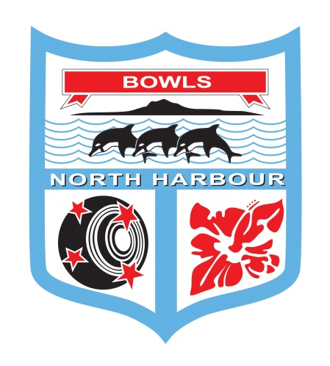

**Bowls North Harbour Inc**

**2021 – 2022**

**Men’s and Women’s**

**Champ of Champ Triples**

**Saturday 7th & 8th May 2022**

**EVENT DIRECTOR – Maureen Taylor Ph: 021 040 9899**

**VENUE**

**HEADQUARTERS AT MANLY BOWLING CLUB**

**Ph: 09 424 7396**

56 Laurence Street Manly

**Saturday** – Men at Manly Bowling Club - 8:30 am

Women at Takapuna Bowling Club – 8:30 am

**Sunday** – Men final at Bowls Orewa – 9:00am

Women final at Bowls Orewa - 9:00am

*For any cancellations – please check the Bowls North Harbour Website & Facebook Page*

**Bowls North Harbour Inc**

**Men and Women Champ of Champ Triples**

**CONDITIONS OF PLAY:**

1. **Laws and Regulations:** Played under the **Laws of the Sport of Bowls** and Bowls New Zealand Domestic Regulations as applicable.
2. **Controlling Body**: The Controlling Body for this event is the Bowls North Harbour Match Committee. The Controlling Body will have the right to alter, add to or delete any conditions of play and/or special conditions to enable the completion of the tournament.
3. **Code of Conduct:** All players will comply with and observe the requirements of the “Code of Conduct for players at Bowls North Harbour Event” as set down in the Bowls North Harbour Centre Handbook.
4. **Clothing**: All players in a team event, or singles players in a singles event, shall wear their club uniforms or other matching sports clothing which is suitable for playing the game of bowls. This means the same shirts and coloured pants (long or short is acceptable) or skirts. Logos that conflict with the event or Bowls North Harbour sponsors will not be permitted. In inclement weather jackets or other suitable outer clothing is acceptable.
5. **Postponements:** Any postponements due to weather conditions will be on the Bowls North Harbour Website & Facebook page.
6. **Mobile phone:** Use is not permitted by players on or alongside the greens during play. It is preferred that cell phones are switched off or turned to silent.
7. **Smoking Policy:** There shall be no smoking on the greens or immediate surrounds. Smoking areas will be designated at each venue as advised by the host club duty officer. Please be advised that some clubs in North Harbour are completely smoke-free clubs.
8. **Alcohol Policy:**  Alcohol shall only be consumed in areas defined by the host club liquor licence and in no event be allowed on the green or surrounds during play.
9. **Late Appearances:** When any player has failed to be in position to commence play **15 minutes** after the scheduled starting time, the game will be awarded to the opponent.
10. **Entry Fees and withdrawals:** Entry fees will be refunded to late entries and entries not accepted. No refunds will be made to teams or players who withdraw after the draw has been made. Any withdrawals must be notified to the Bowls North Harbour office by 12 noon on the day preceding the scheduled commencement of the event.
11. **Defaulters:** No team or singles player will withdraw except in the case of illness of a player or other just cause. The Controlling Body may require evidence of the illness or other just cause to be submitted.
12. **Use of greens** – Bowls North Harbour acknowledges that clubs provide their greens for use in the organisation of centre and national events. At times there may be particular requests by clubs/greenkeepers for play to be in a certain direction and this may well be changed during the course of the event and in some cases during the day. Any such requests are approved as a condition of play for the event.
13. **Trial Ends:** Before the scheduled start of play for the first game of the day or before continuing an unfinished game on another day, or on changing to another green during the day, one trial end may be played in each direction.
14. **Complaints:** The Bowls North Harbour Match Committee will act on any complaints and all playing disputes, provided they are in writing, to the Bowls North Harbour Events Manager.
15. **Breach of Conditions of Play:** Where the Conditions of Play have been breached by any club, team or player then the Controlling Body for the event may take such action as to disqualify, fine or impose such other penalty against the club, team and/or player. Such action may result in the club, team or player from participating in further Centre competitions until the penalty has been discharged.
16. **Media and Communications:** Bowls New Zealand and Centres reserve the right to use any video and photographs taken during this event for further promotional requirements.

**SPECIAL CONDITIONS OF PLAY:**

1. **Play will commence by:**

All8:30am on Saturday 7th May

Men 9.00am on Sunday 8th May

Women 9:00am on Sunday 8th May

1. **Games:** Order of play will be randomly drawn. All games will be sudden death, 18 ends, 2¼ hour time limit. Three games will be played per day.
2. **Bowls:** Each player will play 2 bowls in each end.
3. **Defaults:** If a team defaults their score will be recorded as a loss. The non-offending team will be awarded a win.
4. **Dead Ends**: If an end becomes dead it must be replayed.
5. **Time limit:** All games to be continued irrespective of the score until the designated time limit (2¼ hours) is over or until the game is finished, whichever comes first. If the **jack has been delivered before the time signal** the end will continue and if it subsequently becomes dead it will be replayed.
6. **Time Limit in Final:** There will be no time limit in the final. 18 ends will be played.
7. **Restricting the Movement of Players During Play**: In all games, players will only be allowed to walk up to the head under the following circumstances:

The player who is playing lead or two in the team can visit the head after their 2nd bowl.

The player who is playing skip can visit the head after their 1st bowl.

1. **Tie in Sudden Death play:** All play on both Saturday and Sunday is sudden death so all have to play an extra end if equal after either 18 ends or 2 ¼ hours.
2. **Clothing:** Any winter outer garments are permitted in addition to clothing specified in the conditions of play
3. **Variations to Conditions:** In the case of inclement weather 10 ends will constitute a game. This will only apply to games which have not been commenced. Any games already commenced are required to be completed to 18 ends.
4. **Prize money**: Will be paid in cash at the conclusion of the event to the clubs.



