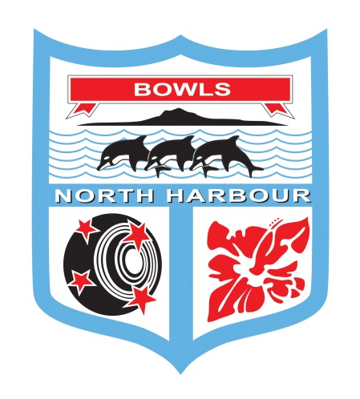

**Bowls North Harbour Inc**

**2021 – 2022**

**Men’s & Women’s Champion of Champion Singles**

**Saturday 23rd & Sunday 24th April 2022**

**EVENT DIRECTOR – NORMA KLAASSEN Mob: 021 140 4866**

**HEADQUARTERS AT MANLY BOWLING CLUB Ph: 09 424 7396**

56 Laurence St, Manly, Whangaparaoa

**Saturday** – Men at Bowls Orewa - 8:30 am

Women at Manly Bowling Club – 8:30 am

**Sunday** – Men final at Bowls Orewa – 9.00 am

Women final at Bowls Orewa – 9.00 am

***For any cancellations – please check the Bowls North Harbour Website & Facebook Page***

**Bowls North Harbour Inc**

**Men’s & Women’s Champion of Champion Singles**

**CONDITIONS OF PLAY:**

1. **Laws and Regulations:** Played under the **Laws of the Sport of Bowls** and Bowls New Zealand Domestic Regulations as applicable.
2. **Controlling Body**: The Controlling Body for this event is the Bowls North Harbour Match Committee. The Controlling Body will have the right to alter, add to or delete any conditions of play and/or special conditions to enable the completion of the tournament.
3. **Code of Conduct:** All players will comply with and observe the requirements of the “Code of Conduct for players at Bowls North Harbour Event” as set down in the Bowls North Harbour Centre Handbook.
4. **Clothing**: All players in a team event, or singles players in a singles event, shall wear their club uniforms or other matching sports clothing which is suitable for playing the game of bowls. This means the same shirts and coloured pants (long or short is acceptable) or skirts. Logos that conflict with the event or Bowls North Harbour sponsors will not be permitted. In inclement weather jackets or other suitable outer clothing is acceptable.
5. **Postponements:** Any postponements due to weather conditions will be on the Bowls North Harbour Website & Facebook page.
6. **Mobile phone:** Use is not permitted by players on or alongside the greens during play. It is preferred that cell phones are switched off or turned to silent.
7. **Smoking Policy:** There shall be no smoking on the greens or immediate surrounds. Smoking areas will be designated at each venue as advised by the host club duty officer. Please be advised that some clubs in North Harbour are completely smoke-free clubs.
8. **Alcohol Policy:**  Alcohol shall only be consumed in areas defined by the host club liquor licence and in no event be allowed on the green or surrounds during play.
9. **Late Appearances:** When any player has failed to be in position to commence play **15 minutes** after the scheduled starting time, the game will be awarded to the opponent.
10. **Entry Fees and withdrawals:** Entry fees will be refunded to late entries and entries not accepted. No refunds will be made to teams or players who withdraw after the draw has been made. Any withdrawals must be notified to the Bowls North Harbour office by 12 noon on the day preceding the scheduled commencement of the event.
11. **Defaulters:** No team or singles player will withdraw except in the case of illness of a player or other just cause. The Controlling Body may require evidence of the illness or other just cause to be submitted.
12. **Use of greens** – Bowls North Harbour acknowledges that clubs provide their greens for use in the organisation of centre and national events. At times there may be particular requests by clubs/greenkeepers for play to be in a certain direction and this may well be changed during the course of the event and in some cases during the day. Any such requests are approved as a condition of play for the event.
13. **Trial Ends:** Before the scheduled start of play for the first game of the day or before continuing an unfinished game on another day, or on changing to another green during the day, one trial end may be played in each direction.
14. **Complaints:** The Bowls North Harbour Match Committee will act on any complaints and all playing disputes, provided they are in writing, to the Bowls North Harbour Events Manager.
15. **Breach of Conditions of Play:** Where the Conditions of Play have been breached by any club, team or player then the Controlling Body for the event may take such action as to disqualify, fine or impose such other penalty against the club, team and/or player. Such action may result in the club, team or player from participating in further Centre competitions until the penalty has been discharged.
16. **Media and Communications:** Bowls New Zealand and Centres reserve the right to use any video and photographs taken during this event for further promotional requirements.

**SPECIAL CONDITIONS OF PLAY:**

1. **Play will commence by:** First round of play will commence at 8.30 am on Saturday 23rd April for both men and women. Players who are not scheduled to play in the first round must report by 10.00 am on Saturday 23rd April Please refer to the draw sheet for details. Sunday play will start at 9.00 am at Bowls Orewa
2. **Markers:** Markers will be supplied by the hosting club for the first game on Saturday 23rd April. Players who have lost in a previous round will be required to mark the subsequent round

**Saturday 23rd April**

**Women Manly:** 6 for game one, losing players to mark subsequent rounds

**Men Orewa:** 7 for game one, losing players to mark subsequent rounds

**Sunday 24th April:**

**Finals Orewa:** BNH will mark the finals

1. **Losing Players**: **Will be required to mark the following game.** Players must **NOT** leave the venue before checking with the Event Director
2. **Games:** Order of play will be randomly drawn. All games will be sudden death, 21 Shots, no time limit.
3. **Bowls:** Each player will play 4 bowls in each end.
4. **Defaults:** If a player defaults their score will be recorded as a loss. The non-offending player will be awarded a win.
5. **Time limit:** There is NO time limit for the Singles Competitions.
6. **Restricting the Movement of Players During Play**: In all games, players will only be allowed to walk up to the head under the following circumstances:

After delivery of their third and fourth bowls

In exceptional and limited circumstances, a singles player can ask a marker for permission to walk up to the head earlier than described above.

If a player does not meet the terms of this law, Law 13 will apply.

1. **Clothing:** Any winter outer garments are permitted in addition to clothing specified in the conditions of play
2. **Prize Money:** Prize money will be paid in cash after the conclusion of the event to the clubs.



